**AZURE CI/CD PIPELINE**

1. ***Continuous Integration of web app using GitHub***:

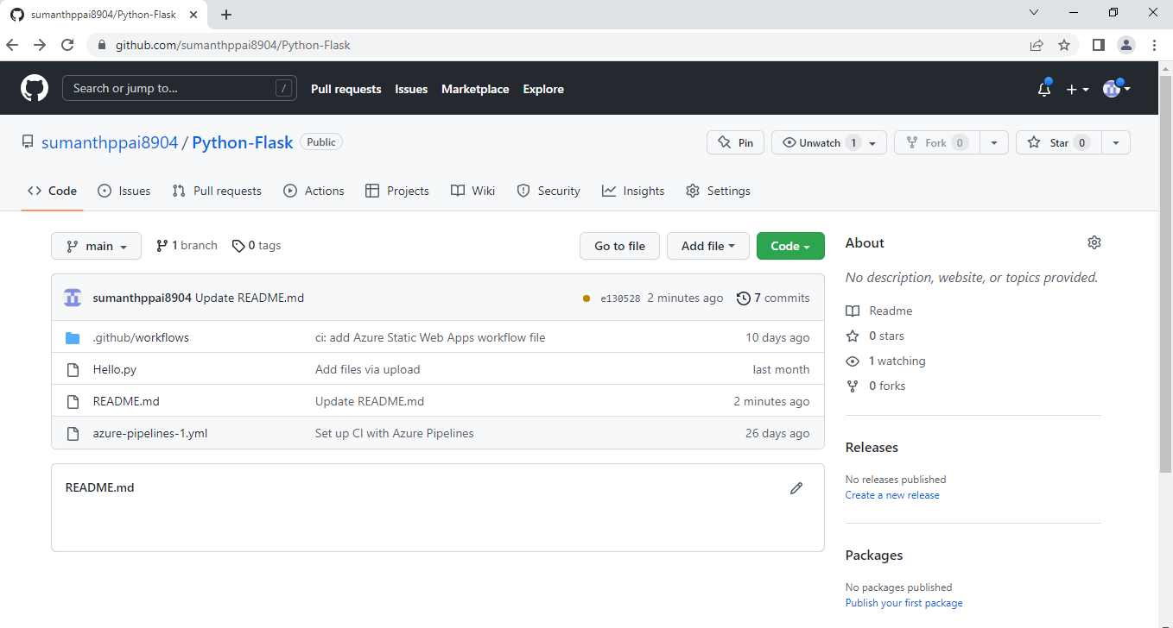

* Created a repository and pushed the Python code file “Hello.py” into the GitHub.

1. ***Creation of CI Pipeline in Azure***:

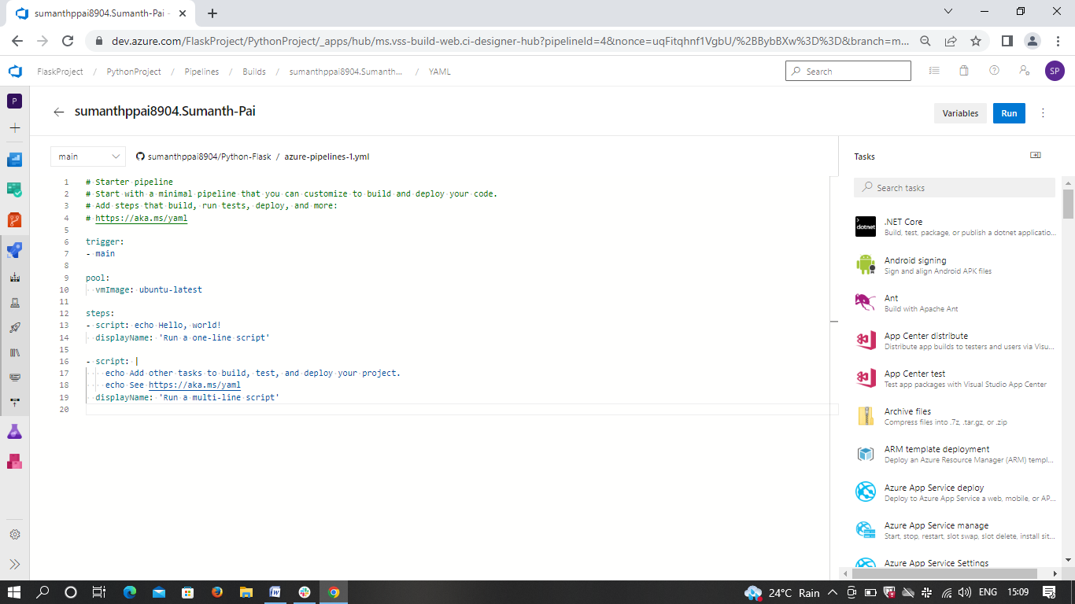

* Created a CI Pipeline using YAML Script.

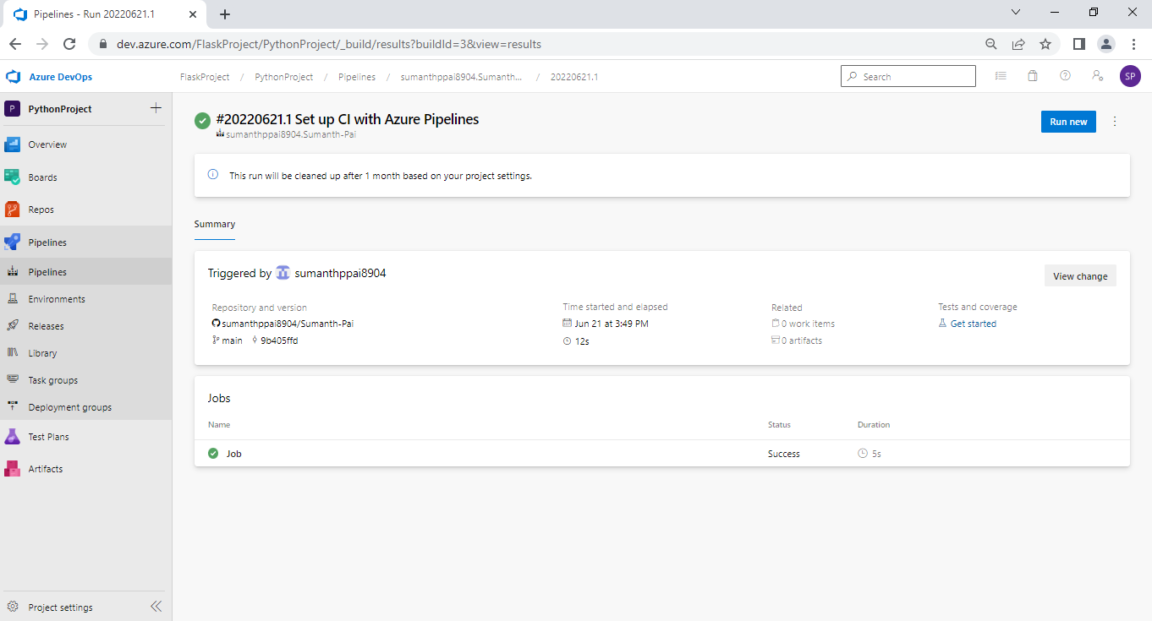

* YAML script validation runs successfully.

1. ***Creation of Virtual Machine in Azure***:

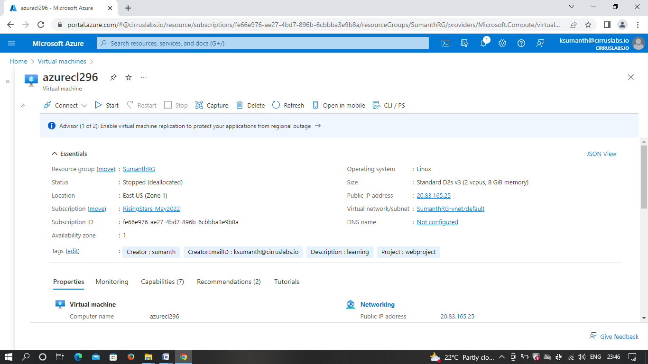

* In the Azure portal, first I have created a virtual machine to run the web app by connecting to GitHub account.
* Once after successful validations, VM gets automatically launched into the resource as per the above image.

1. ***Creation of Static web app***:

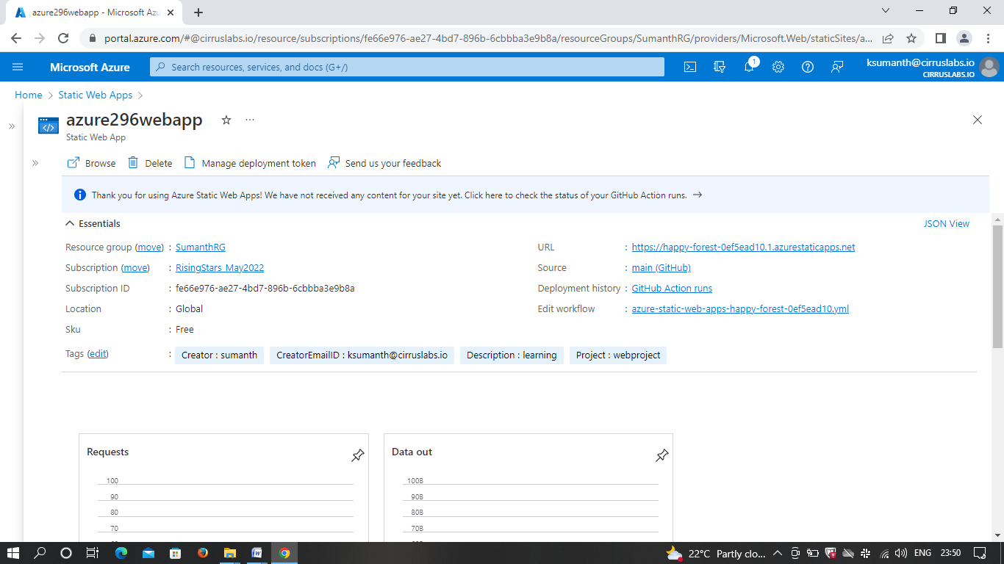

* After the completion of VM, second step is to create a static web app which builds and deploys full stack web apps to Azure from a chosen code repository.

1. ***Deployment of App services in Azure***:

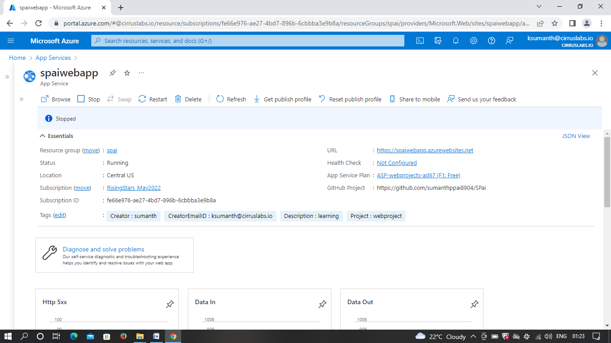

* Once after the creation of static web app, third step is to create a web app and deploy it into the app service by selecting appropriate programming language and framework i.e., Python (Flask) in order to run it in Visual Studio Code.
* Fourth step is to setup a virtual environment for the app using the command.
* Once after the setup, next step is to install the dependencies in Visual Studio Code to run the app.

1. ***Running the app in VS Code***:

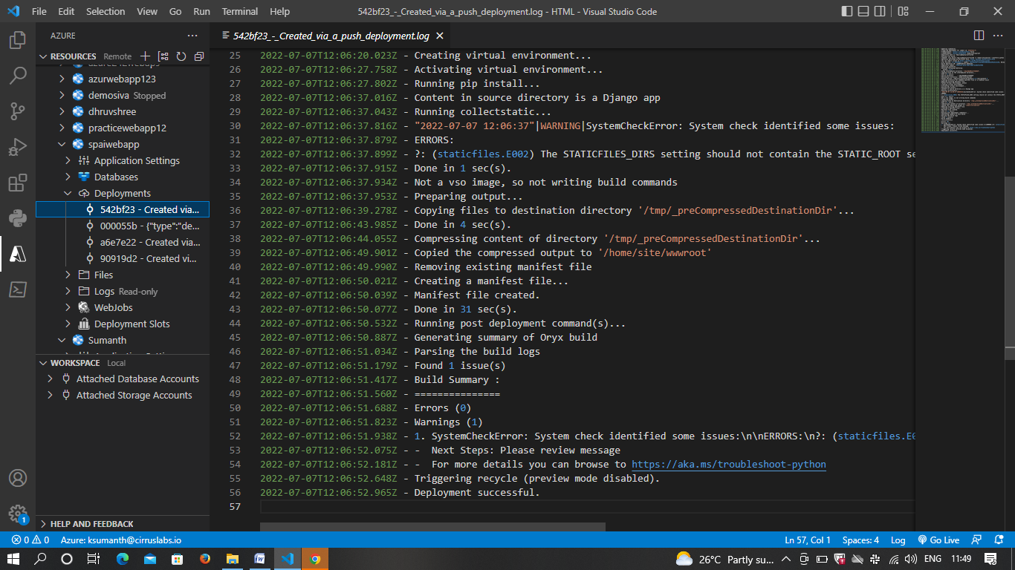

* This is the program where deployment gets successful after running the app in VS code.
* After deployment, next step is to click on the URL of the web app in the portal which redirects to Azure website that I have created as mentioned below.



1. ***Home page of the web app***:

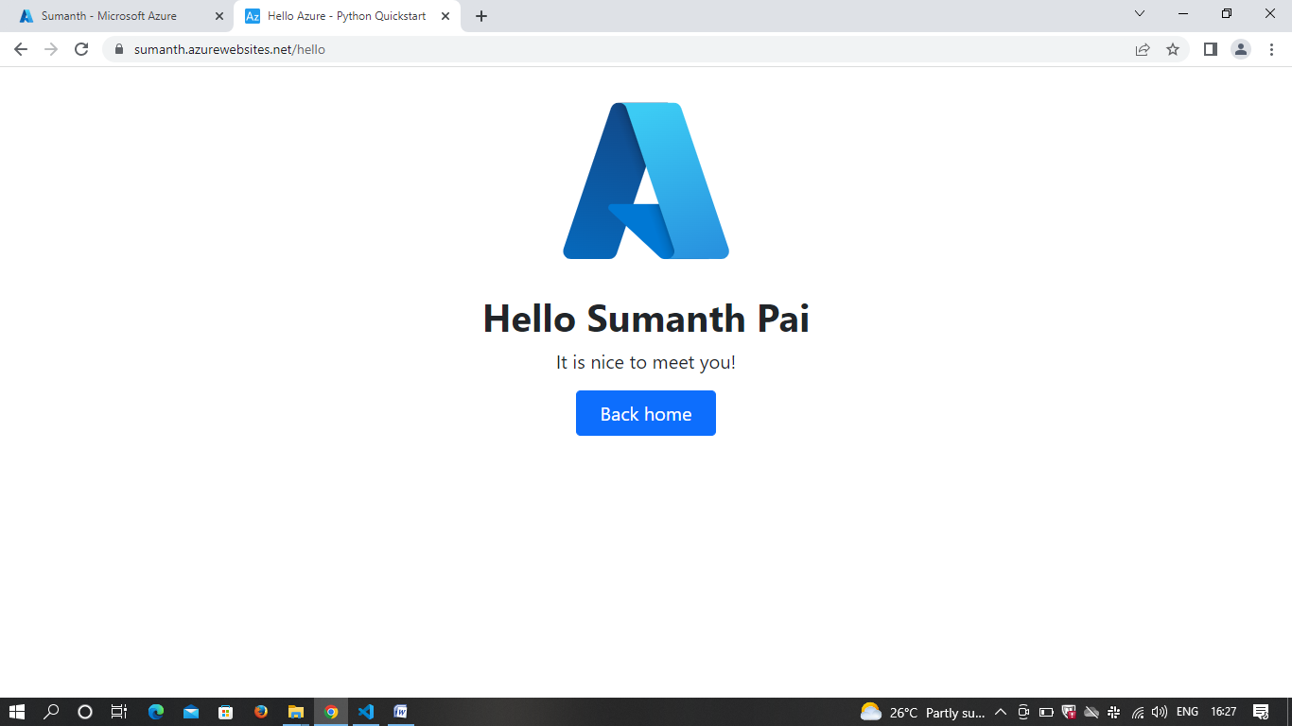

* This is the final homepage of the web app that I have created.